One Park Road

Luxury Windermere Accommodation

Summer 2021 Newsletter.

Hello again from Windermere. How lovely to hear the doorbell ringing and me welcoming guests back again. Although I am currently only operating at a reduced occupancy to ensure my guests feel safe. Let’s hope life returns to more normality as from the 19th July (fingers crossed)

What a soggy spring we have had! The plants really have had a hard time with late frosts as well as lots of rain. As I type this the whole of the UK is basking in glorious sunshine (what am I doing indoors and not enjoying the sunshine – well, it is check in time for guests!)

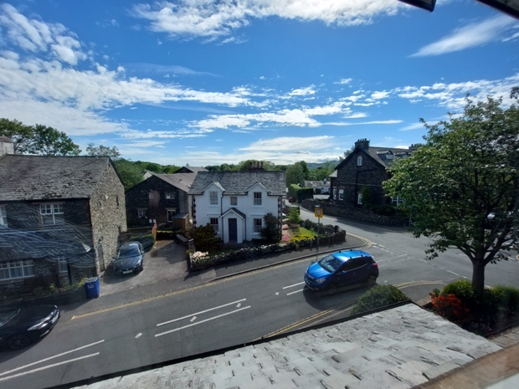

A couple of things to mention here :

- I do not offer a luggage storage facility, if you arrive in Windermere early, please enquire about leaving your luggage at Windermere tourism, a short walk from the train station – further details can be found here https://www.windermereinfo.co.uk/visit-windermere/luggage-storage/
- All new bookings are a minimum of 2 nights these days. If you feel that your towels need to be changed after the first night there will be a £7.00 surcharge for replacing the towels with fresh ones.

There is now a private dining at breakfast option in the guesthouse, please ask if you need any more information.

So looking forward to a reduction of restrictions so guests can fully utilise the communal fridge and enjoy a buffet style breakfast in the mornings.

We had some dry evenings a few weeks ago and I toom some night shots of the Guesthouse.

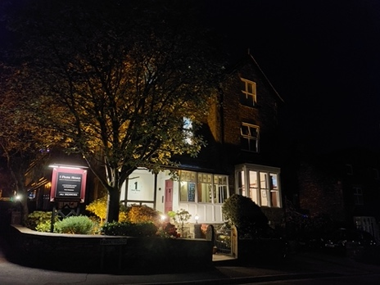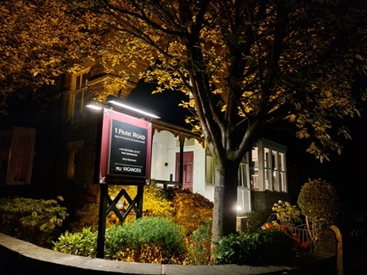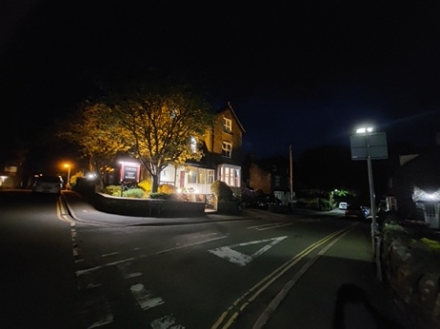

I had opportunity of having some Youtube Vloggers come and do a review of the Guesthouse from a biking point of view stay. Please note – any cyclists wanting to stay here, yes there is safe bike storage but it is not under cover. Here is the link to the Youtube video.

Not much has happened that I can report on, the whole Lake District is really very busy these days, so nice to see people out and about again.

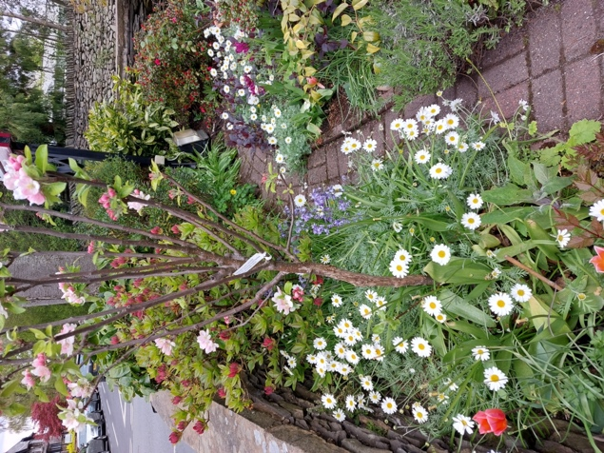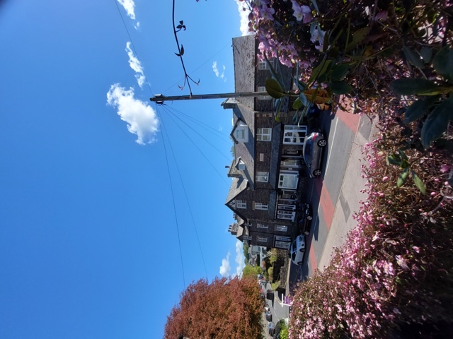

Please remember that if you book directly with me you automatically get a 10% discount.
If you have any questions, please feel free to drop me an email enquiries@1parkroad.co.uk or give me a call on 015394 42107.

I trust that I will see some returning guests in the not-too-distant future. If you are going to be revisiting or coming to stay for the first time, you will be given a hearty welcome!

Warm Regards

Hilton

