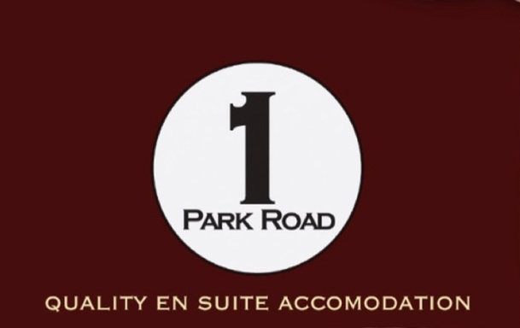

Newsletter Winter/Spring 2024

Hi and thanks for taking time to have a quick read of my 2024 newsletter. These newsletters are few and far between as during the busy months I just don’t have time to get them done.
Currently the business is closed but will recommence as from February 2024.

2023 was a successful year – bookings were up, and I am pleased to say that a lot of these bookings were repeat business – thank you! Sadly, with the cost of everything these days I have had to increase the cost of the rooms per night as well. The biggest price increases being gas and electricity. Of course, consumables and food are still expensive, let’s hope that they start coming down in the next few months. If you want a good discounted holiday deal, why not book with me directly?

2023 also was the year of celebrating 1 Park Road’s existence of 140 years. I, as well as close relatives, suppliers and our local government Minister all came through in March to celebrate this milestone.

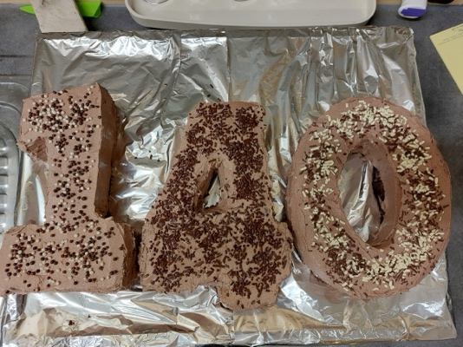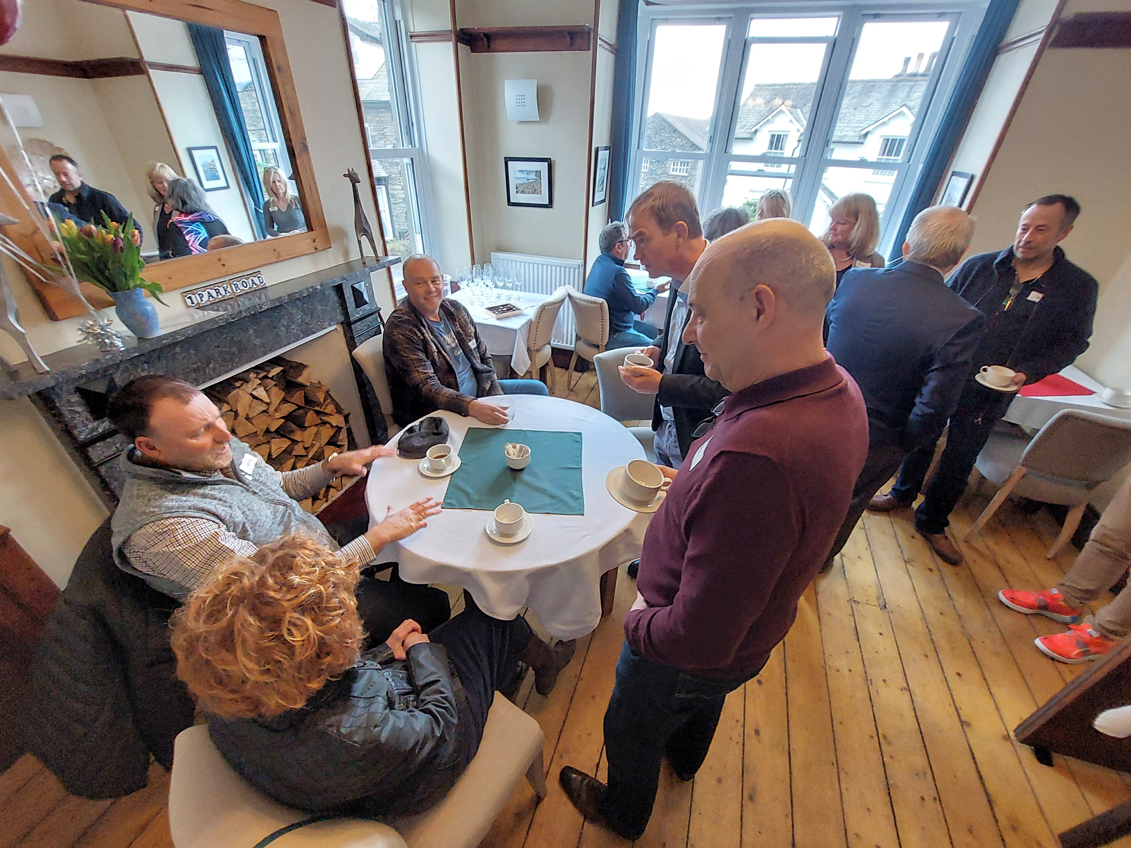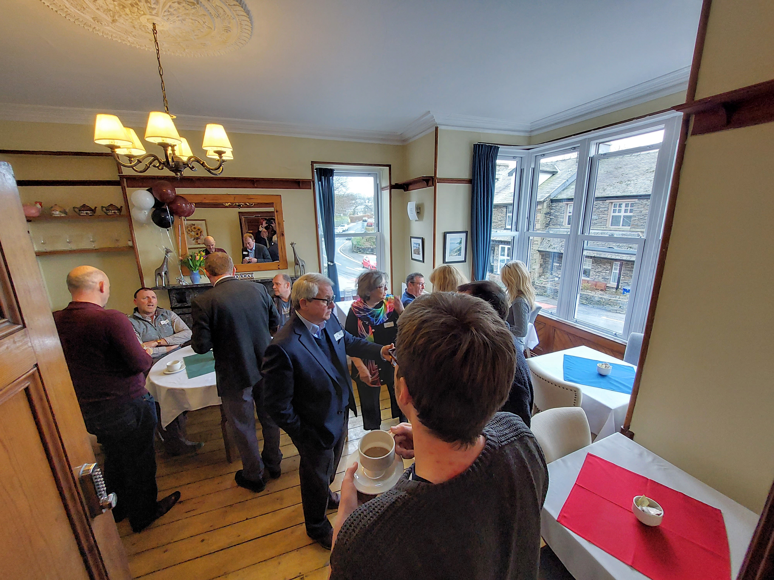

The King’s Coronation was a jolly affair here at 1 Park Road as well as in Windermere town itself.
Any opportunity to air the bunting!

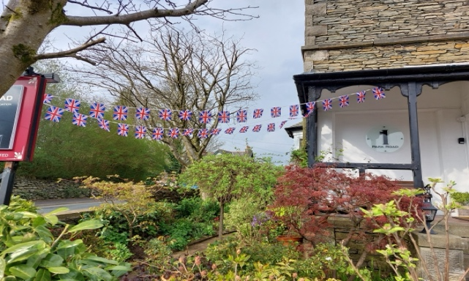

Some necessary exterior building work had to be done during the early months of 2023, this caused a bit of chaos traffic wise. Guests were entertained with a monstrosity of a cherry picker on the parking lot and traversing between bedroom windows. However, it was all done on time. I heaved a huge sigh of relief when the beast was rolled onto the flat loader and was driven away.

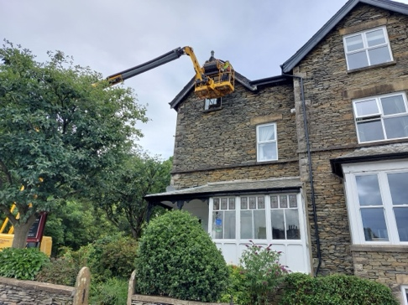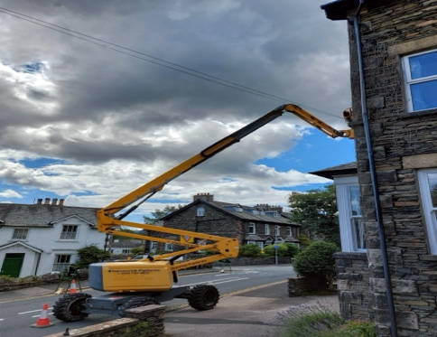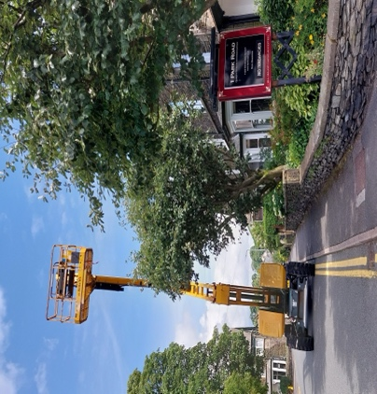

Climate change has become very evident here – we were battered with storm after storm here and I think we endured just over a foot of snow late in the year. On speaking to local friends, they said that this snowstorm was the worst in 25 years. So pretty it was until it tuned to ice!

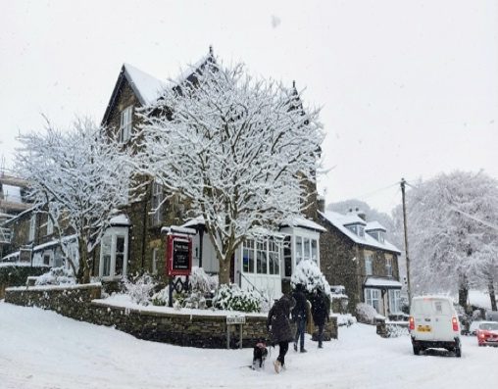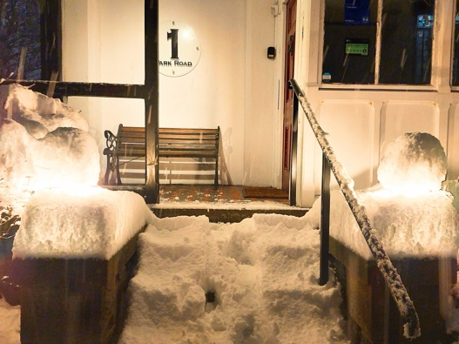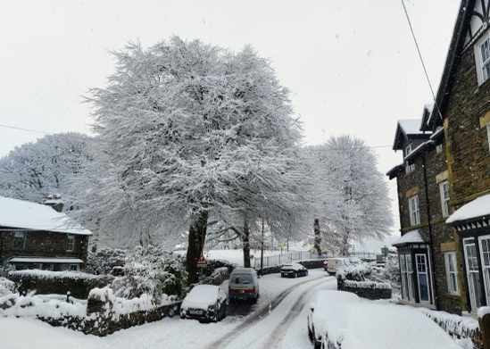

Touch wood, I have been very fortunate that there has been no structural damage to the property during these storms, being on a slight hill away from becks (streams) and not having huge trees on or near to the house is reassuring that 1 Park Road survives what is thrown at her.

I am pleased that my ‘scores on the doors’ food/kitchen standards again have been given a 5/5 certification.

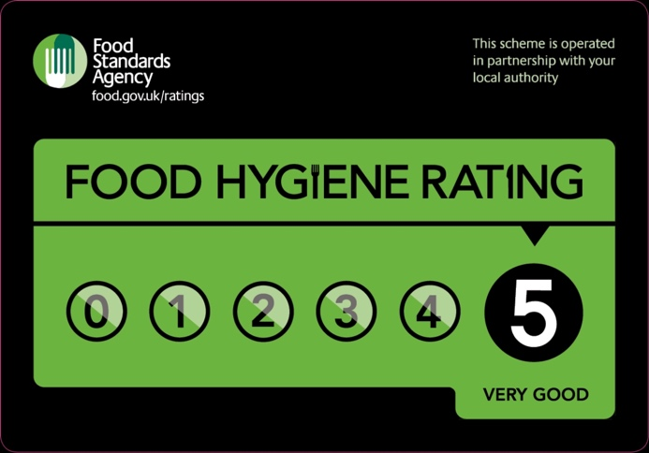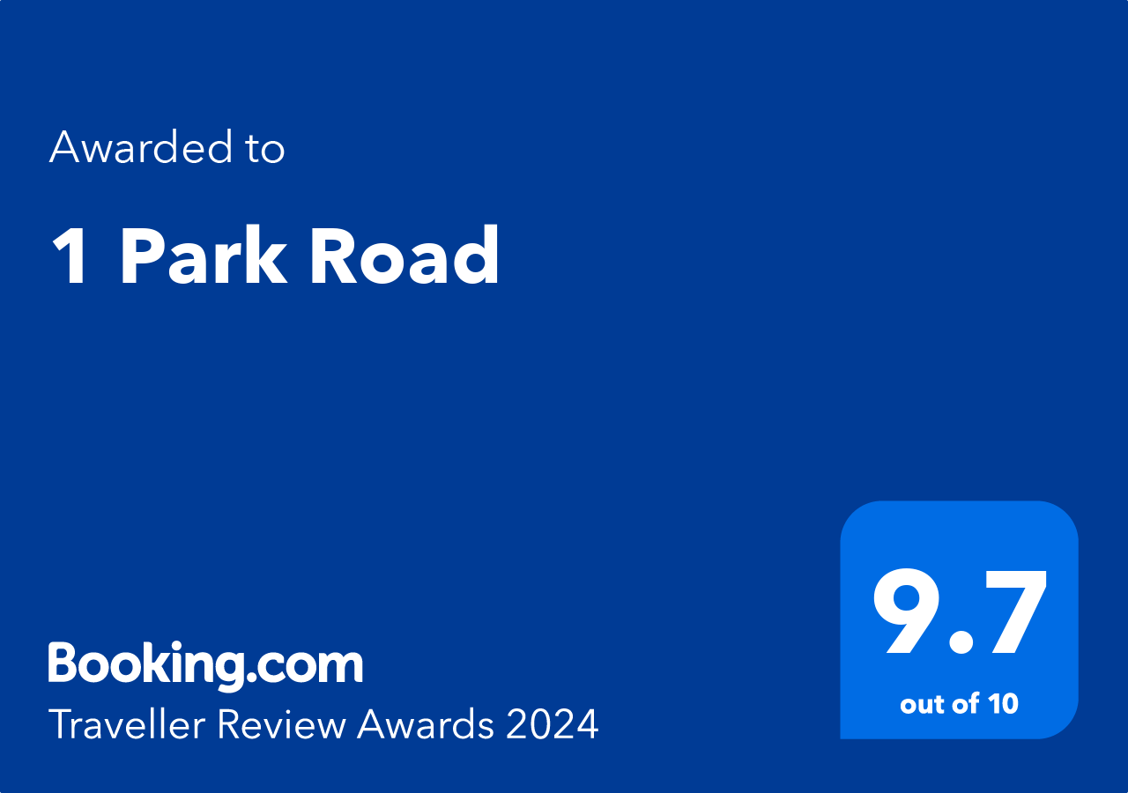

Speaking of ratings, I am very pleased to announce that my reviews rating with Booking.com has increased to 9.7 – it is a lot of hard work – and the results say it for themselves. Thanks to all guests in the past that have reviewed me in a positive way. However, I do hope that if there is a problem while staying with me that you would be kind enough t
point this problem out to me so it can be addressed there and then.

Spring is a wonderful time of the year – new life and colour fills our days. The gardeners planted about 150 additional bulbs in the large flower bed adjacent to the parking area. I look forward to seeing a spectacular display soon.

1 Park Road does have a Facebook page, so please feel free to follow me there with any updates through the year. It is far quicker to upload a news feed or a range of images there than to wait until another newsletter is produced.

I do hope that if you are planning to visit the Lake District that you would consider coming to stay at 1 Park Road – either as a retuning guest or a new one, you will always be most welcome!

Bye for now!

Hilton

